English Vocabulary – ‘Prize’ vs ‘Award’ (PT: prêmio)

Prize
This is something which is given to a winner, or if you do something well.
- a race
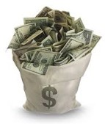
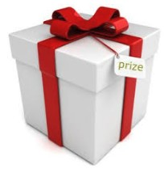
- a TV show contest
- a school competition
- claw machine
- good performance at work
- good behaviour at school

Award
This is something that is given to someone for doing something excellent. It offers encouragement to others to also do good things. If you receive an “award”, it is recognition for an accomplishment.

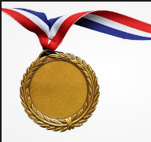
- best actor in a film
- excellent service in charity work
- a medal for bravery in a battle during war
Medal Trophy
Emmy Awards
American awards that recognize excellence in the television industry.
Example: Best lead actor (2018): Benedict Cumberbatch – “Sherlock Holmes”
Academy Awards
American awards that recognize excellence in the film industry.
Example: Best movie (2018): “The Shape of Water”
Tony Awards
American awards that recognize excellence in the theater industry.
Example: Best Musical (2018): The Band’s Visit
Grammy Awards
American awards that recognize excellence in the music industry.
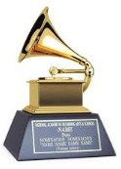
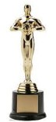
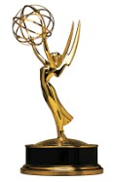
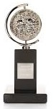
Example: Song of the Year (2018): “That's What I Like” by Bruno Mars

